Outdoor Education Plan
Lesson Focus – Knowledge of Autumn – deciduous trees, hibernation, planting bulbs
Year Group - |  | Term - | Date – Week
 | Outline | Curriculum Links/  Learning Objectives | Health and Safety considerations | Equipment
Session Procedures | Before - Check for rubbish, glass, hazards. Check weather forecast  During – Watch that children do not try to cut corners around the school grounds  - Children must wear gloves for litter picking and planting  After – clear everything away and return any natural objects to their original place  Clean hands using sanitizer. | I understand that some plants and animals are dormant in the winter.  Yr 5/6 – I understand that the seasons are the effect of our position to the sun.  Science  - Dormancy in animals and plants  - Sun, Earth and Moon  Art  - 3D design  - sculpture  PSHE  - Looking after our environment | Wash hands after touching outside objects  Remind the children about how sharp some sticks can be and to be careful of brambles and stinging nettles.  Remind children to be careful not to let the sticks fly out of their hands and go in someone else’s eye.  Gloves must be worn for both litter picking and gardening | Clay  tools  Aprons
Introduction and Activity Opportunities | Problem Solving Activity – Obstacle Course. Blindfolded team member is directed across the space by team who must guide them across/around/under obstacles.  Main Activity – Understanding the significance of Autumn  - Recap – What are the seasons?  - Discuss why the earth has seasons – earths’ proximity to the sun.  - Discuss what changes we expect to see on the next month?  - First we are going to do 20 minutes litter picking in the grounds, why should we do this? http://www.bbc.co.uk/news/uk-wales-south-east-wales-29125880  - Second we are going to make clay hedgehogs/hoglets – see attached instructions  - http://www.bbc.co.uk/nature/adaptations http://www.bbc.co.uk/nature/adaptations/Hibernation  - http://www.bbc.co.uk/nature/life/European_Hedgehog  - What do hedgehogs do in the winter? What sort of place do hedgehogs need to hibernate in? Why do we have to leave wild areas for them? What are the main threats to hedgehogs? What other animals hibernate? Which plants are dormant in the winter?  - What is clay? The layers of soil are created over thousands of years…?  - Wet weather – Hedgehogs are being made in the outdoor classroom. |  |  | Vocabulary
Autumn
Seasons
Earth
Sun
Rotation
Year
Hibernate
Hedgehog
Hoglets

Plenary | Plenary – Discuss autumn – look at pumpkins, onions, strawberries in garden. | Evaluation

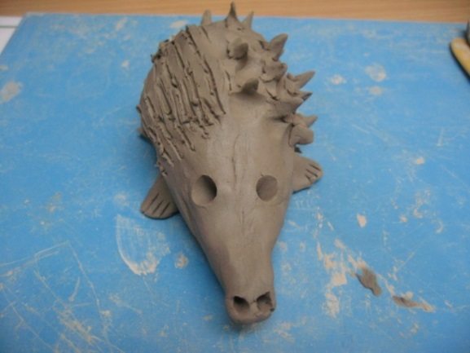
How to make a clay hedgehog
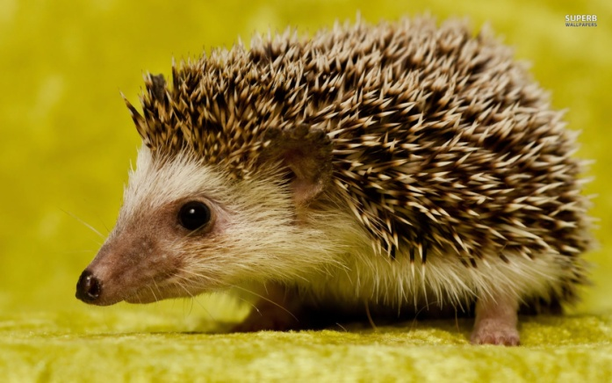
Hedgehog info - http://www.bbc.co.uk/learningzone/clips/the-changing-seasons-hedgehogs/10448.html
1 | Form a ball with the clay  (being careful not to push too much air into it) | 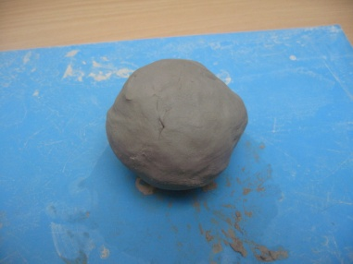
2 | Next push the ball into a teardrop shape (to create the nose). | 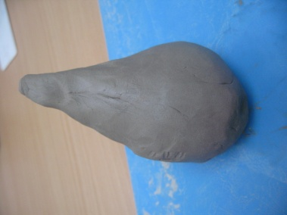
3 | Using a tool push two eyes and nostrils onto the pointed part of the shape. | 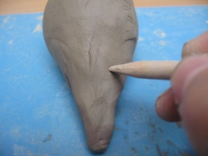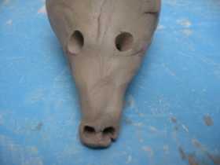
4 | Push down the bottom of the ball and push out 4 feet from the bottom. (You can put toes on if you like). | 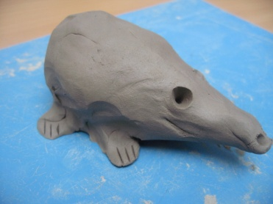
5 | Using a fork/clay tool push along the clay to make needle lines or prick out the clay to make spines. | 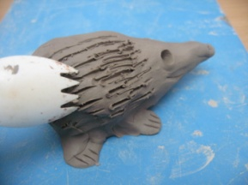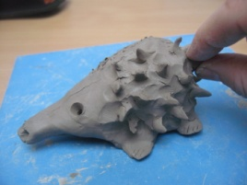
6 | Lastly carefully squeeze out an ear on either side of the head. | 